Project Title: Hosting a Static Website for Attendance Calculation on AWS S3

Abstract: The project aims to design and host a static website for managing and calculating student attendance using Amazon Web Services (AWS) S3. The website enables students to submit attendance requests, and administrators can approve them to maintain accurate attendance records. Leveraging S3 for static website hosting provides a cost-effective, scalable, and highly available platform. This approach eliminates the need for traditional web servers, ensuring faster deployment and simplified management. The project demonstrates the integration of cloud services for efficient web hosting and basic attendance management functionalities.

Objectives: 1. To create a static website for student attendance submission. 2. To host the website on Amazon S3, enabling global access. 3. To allow administrators to approve student attendance requests. 4. To implement a simple interface for viewing and managing attendance data. 5. To demonstrate cloud-based static website deployment and management.

Tools and Technologies: - AWS S3: For static website hosting. - HTML/CSS/JavaScript: For building the frontend of the website. - AWS IAM: To manage access permissions. - JSON / Local Storage: For storing attendance requests. - Web Browser: For accessing the hosted website.

Project Description: The project is a web-based attendance management system designed for educational institutions. Students can submit their attendance requests through the website, and these requests are sent to an admin account. The admin reviews the requests and approves or rejects them. Once approved, the attendance is updated in the system.
AWS S3 is used for hosting the static website, providing a cost-effective and scalable solution. The website consists of: 1. Student Page: For submitting attendance requests. 2. Admin Page: For reviewing and approving requests. 3. Attendance Summary Page: To display approved attendance records.

System Architecture: 1. Frontend: HTML, CSS, JavaScript files hosted on S3. 2. Hosting Platform: AWS S3 bucket configured for static website hosting. 3. Data Handling: Local storage or JSON files to manage attendance data. 4. Access Control: AWS IAM roles to secure admin access.
Flow of Operation: - Student submits attendance request → Admin reviews → Admin approves/rejects → Attendance record updated → Summary displayed.

Advantages: - Easy deployment and hosting using AWS S3. - Cost-effective and scalable solution. - No server maintenance required. - Provides a simple interface for students and administrators. - Reliable and globally accessible.

Output

AWS S3 Setup and File Hosting
- S3 Buckets: Shows the bucket projectmy1 created for the website hosting.

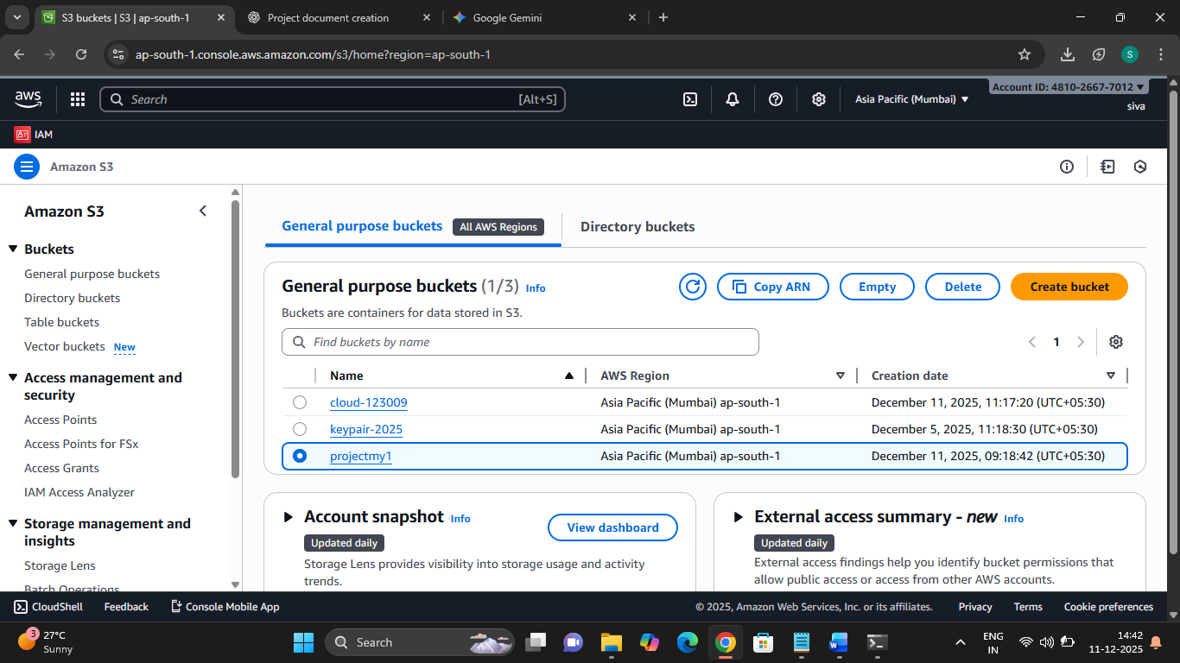

Object Listing: Confirms the main application file, index.html, is uploaded to the S3 bucket.

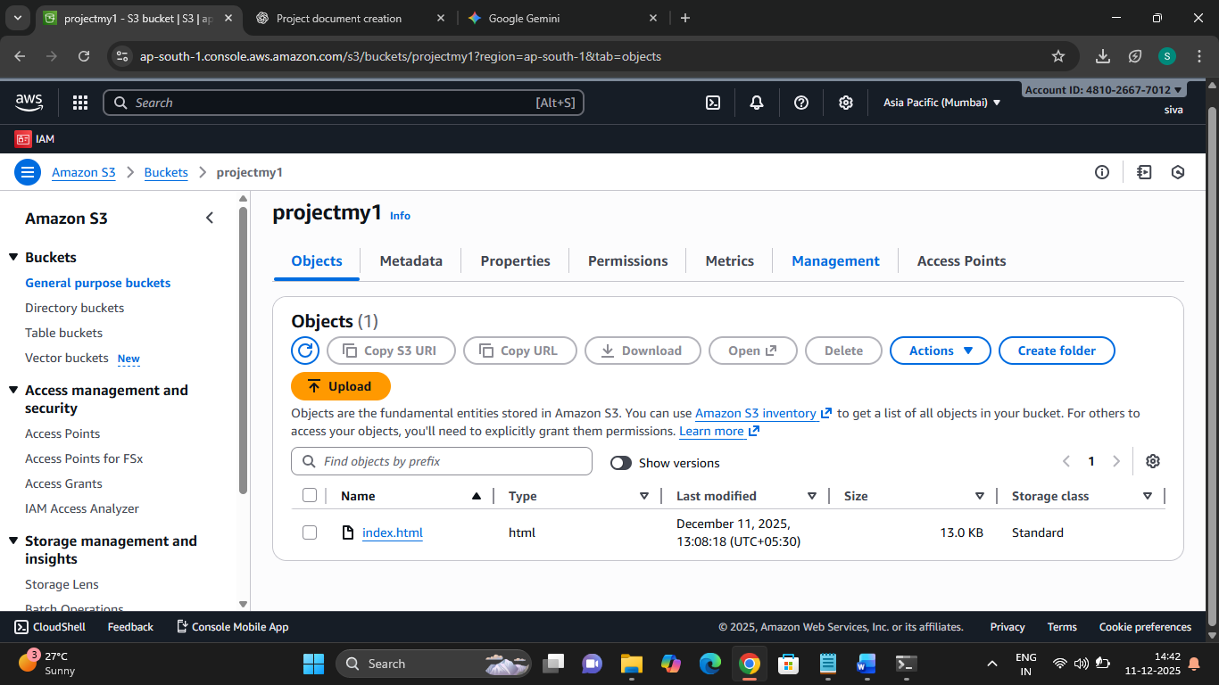
Object URL: Displays the direct URL used to access the static website hosted via S3.

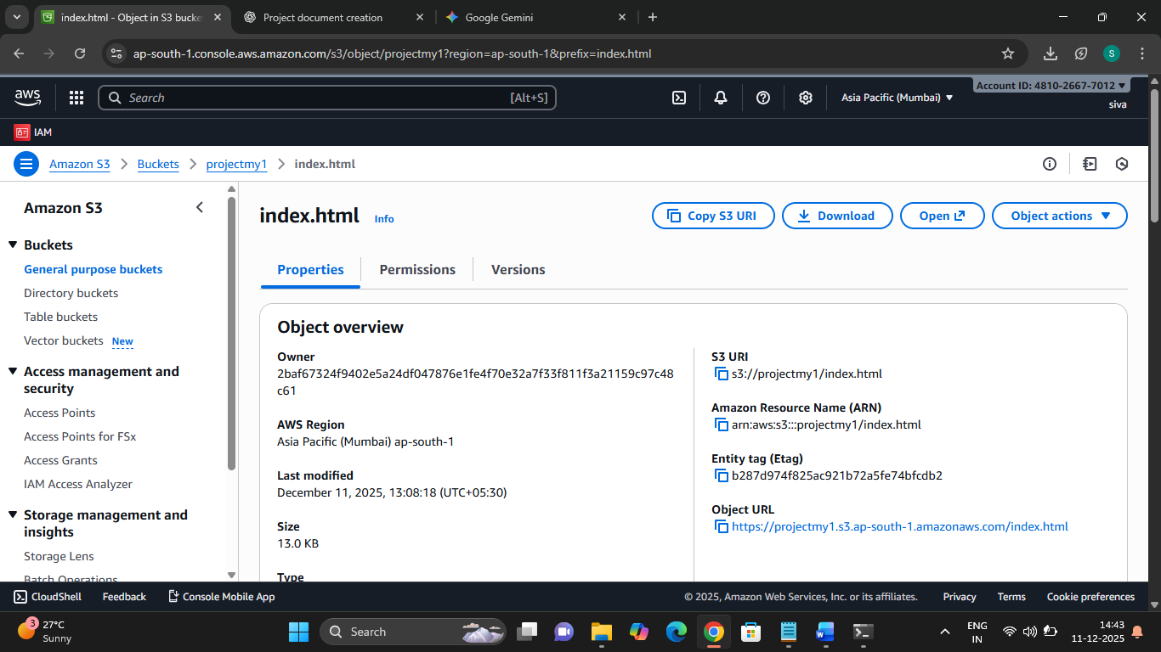

- Login Page

This is the initial screen for accessing the Attendance System, allowing users to log in as either an Admin or a Student.

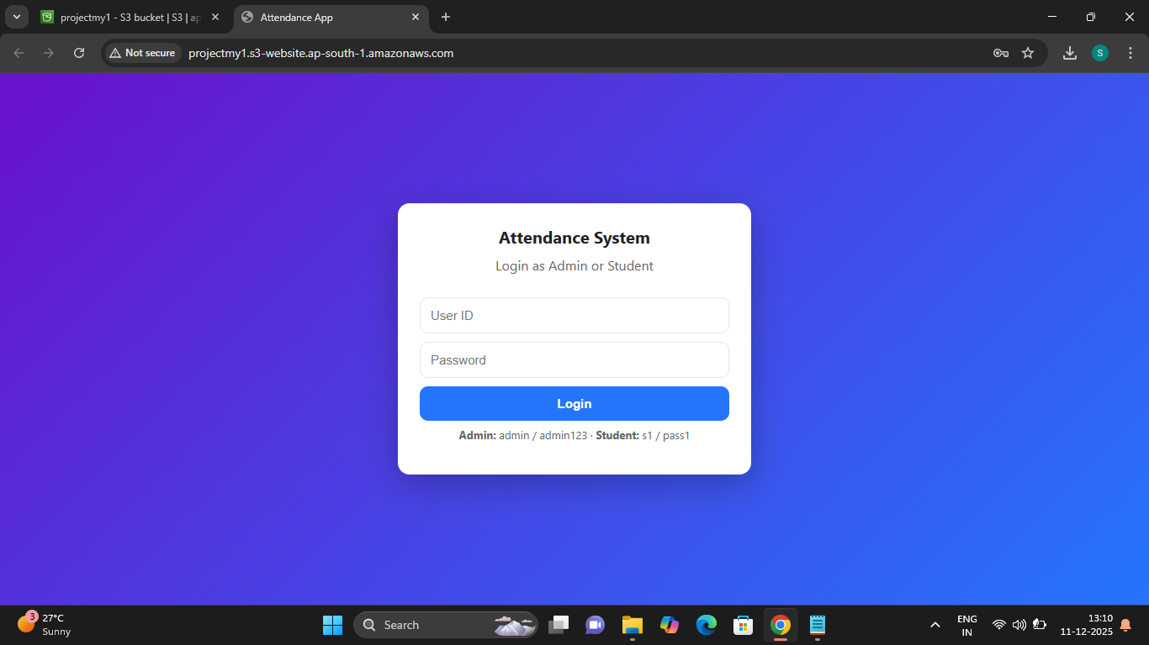

- Admin Panel

This page is used by the administrator to set the valid attendance location and time. It also handles request management.

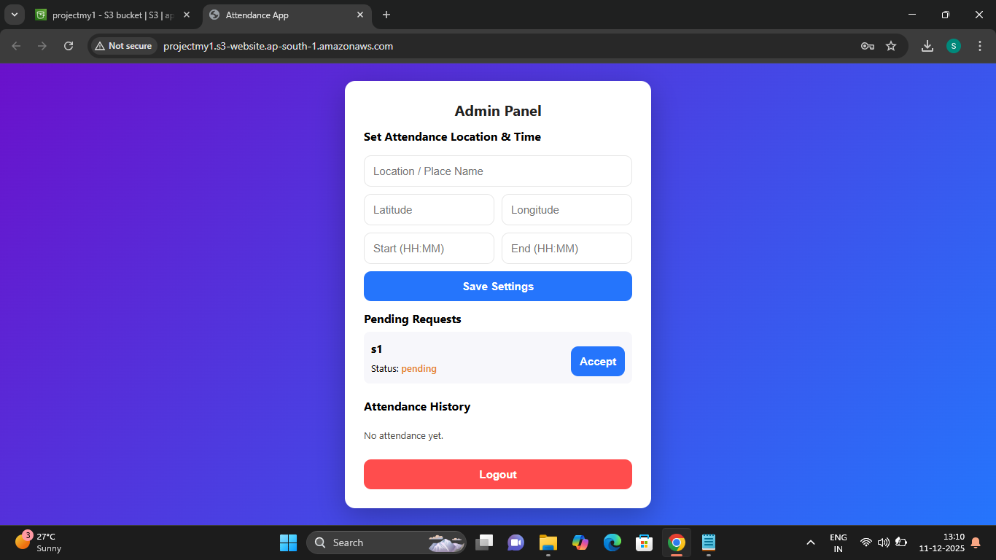

- Student Panel (s1)

- Request Submission: The student submits an attendance request, and the status changes to "Pending approval...".

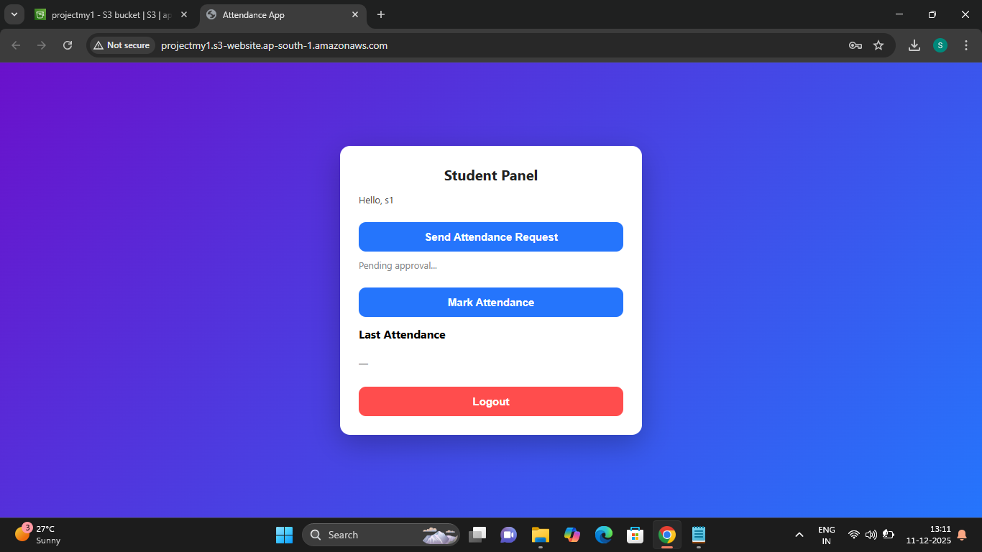
- Admin Panel

- Request Approved Status: After acceptance, the status is updated to "approved".

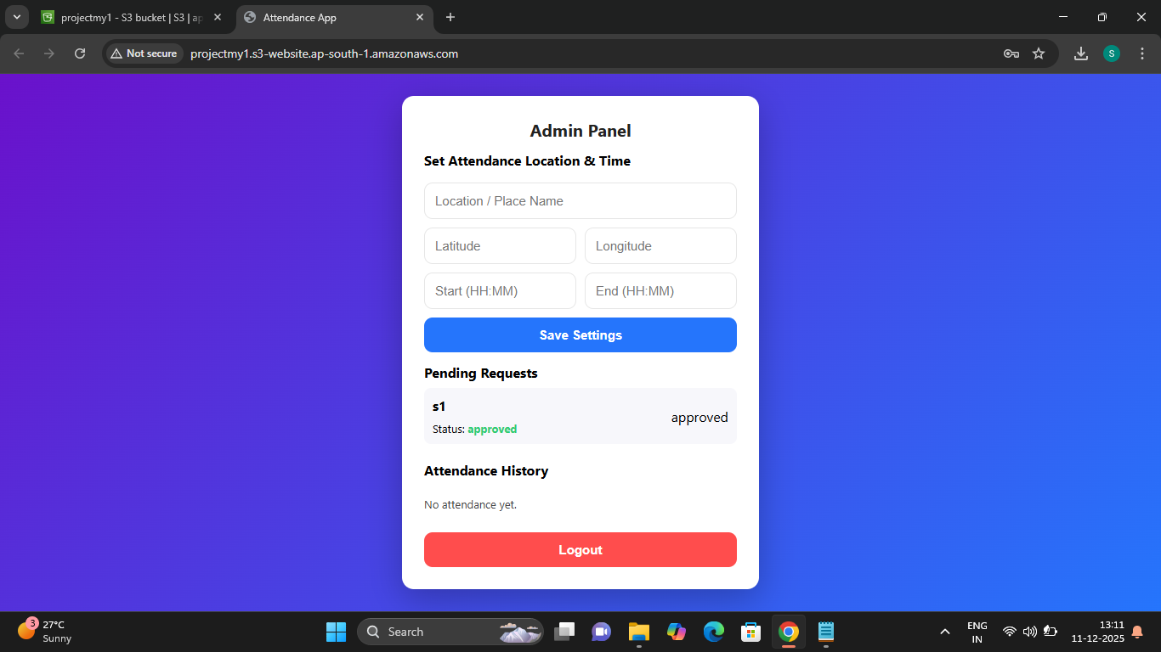

5. Student Panel (s1)

- Request Approval: After the admin approves, the student sees the confirmation: "Approved ✅ You can now mark attendance."

